SPRING WORD SEARCH

T | C | Q | J | C | L | O | U | D | Y
X | J | R | A | I | N | Y | B | E | E
L | A | D | Y | B | I | R | D | I | Z
B | U | T | T | E | R | F | L | Y | O
C | S | U | N | N | Y | B | I | R | D
Y | D | A | I | S | I | E | S | P | F
W | S | N | O | W | D | R | O | P | S
G | U | N | G | R | A | S | S | B | J
S | P | R | I | N | G | W | A | R | K
N | M | O | L | E | A | V | E | S | W

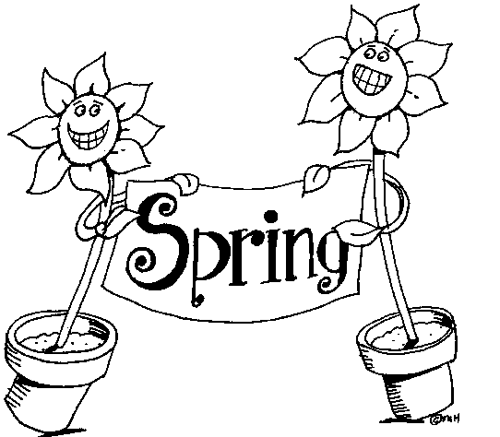
SPRING
SUNNY
CLOUDY
RAINY
LADYBIRD
BEE
BUTTERFLY
BIRD
GRASS
SNOWDROPS
LEAVES
DAISIES

